

**DISCRETE MATHEMATICS PROJECT**

|  |  |  |  |  |
| --- | --- | --- | --- | --- |
| **PROJECT NAME** | **BRICK BREAKER** | | **DATE OF SUBMISSION** | 02-JAN-23 |
| **PROJECT DESCRIPTION** | | Brick Breaker Game | | |

**GROUP MEMBERS**

|  |  |  |
| --- | --- | --- |
| **NAME** | **CLASS** | **REGISTRATION NUMBER** |
| ARISH AMIN | BSCS-3B | 2112140 |
| MUBEEN NAUSHAD | BSCS-3B | 2112151 |

**PROJECT SUMMARY**

|  |
| --- |
| This project Brick Breaker is a game in which the concepts of Discrete Mathematics are applied. A ball is released in the start of the project to hit the bricks. If the ball hits the brick 5 points are added in the score. Total there are 27 bricks and each brick contain 5 points. If the ball goes out of bound which the the window screen of the game the game is over and if all the bricks are finished then you won with the total score showed asking (do you want to play again?) |

**PROJECT OVERVIEW**

|  |  |
| --- | --- |
| **FEATURE** | **DESCRIPTION** |
| SCORE | For adding a new apartment in lists of avaiable rental places. |
| PLAY AGAIN OPTION | For viewing the availability and types of rental places. |
| GUI (GRAPHICAL USER INTERFACE) | Renting an apartment accordingly. |

**PROJECT SCOPE**

|  |
| --- |
| Our project is a minigame revolving around the principles of discrete mathematics, which are to be discussed later on such as, graphs, conditions etc. The game is known as brick breaker, and will be further discussed in its functionalities. The game developed has used different principles in discrete maths and is further open to any updates regarding it. This game has used GUI and Graphical Interaction that makes it more interesting for multiple uses.  From explaining discrete maths through the game or simply enjoying it. Variety of functions are available like scoring. |

**CODE WHERE DISCRETE MATHS LOGIC IS APPLIED**

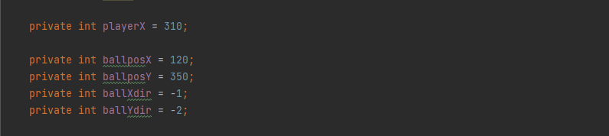

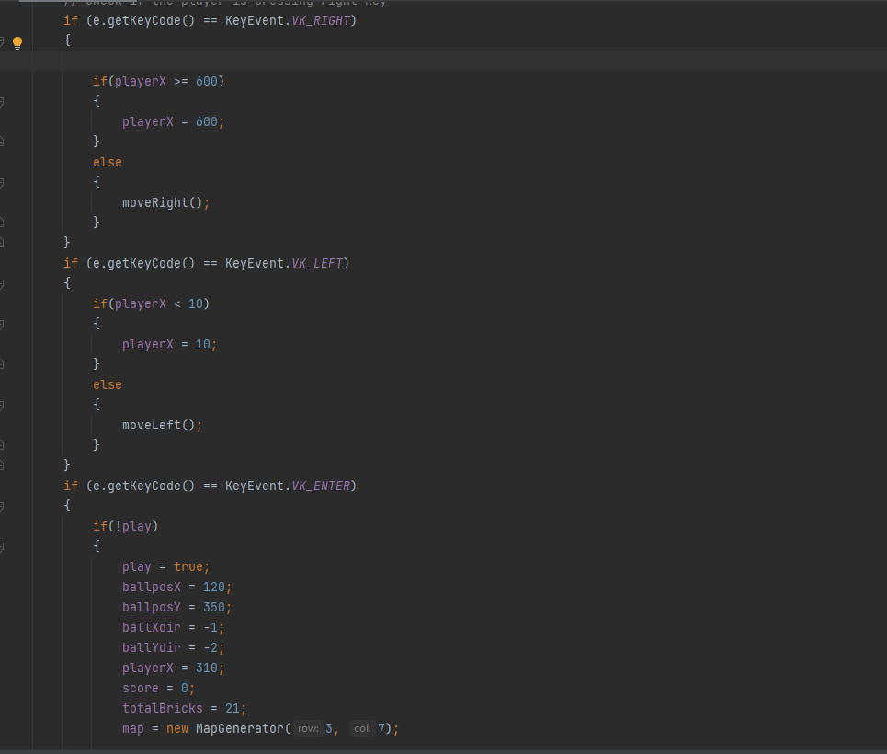

S

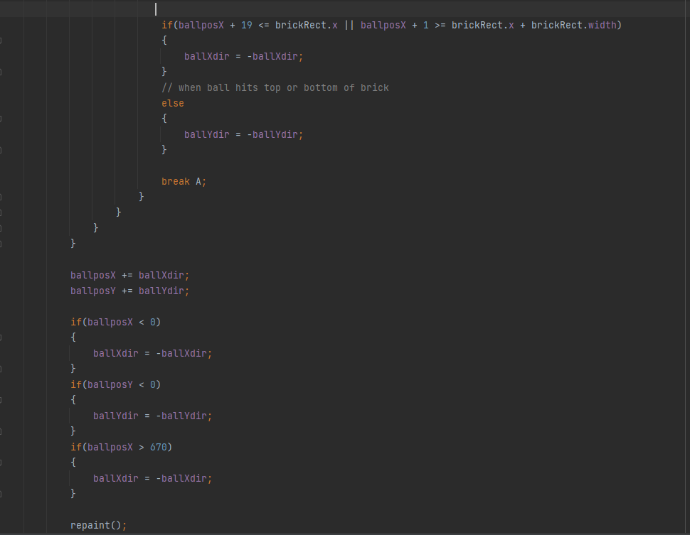

|  |
| --- |
| The concepts that are used in this project are   1. Conditional Statements: A Conditional Statements are those statements which are used to instruct the compiler/computer what to do in several circumstance and using IF-Else condition we direct the compiler to perform certain task if the button is pressed 2. Map Coordinated: The X and Y directions are used to place the blocks and ball on the certain coordinates and to move in the given x and y directions. |

**OUTPUT**

**MAIN SCREEN:**

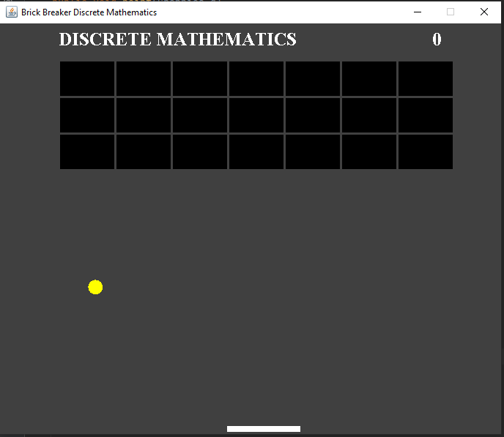

**GAME OVER:**

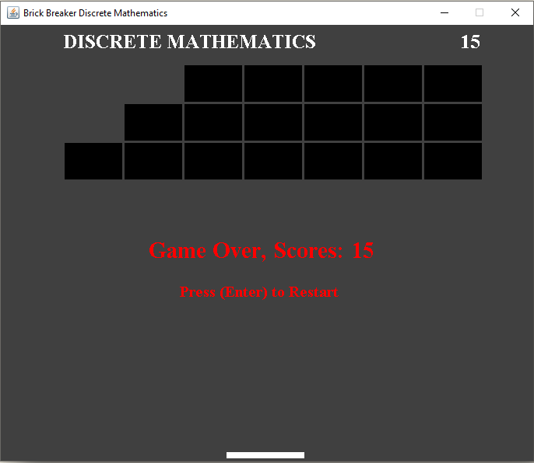

**GAME WON:**

